12/19/2016

IS 661 Group Project

GROUP 10

“Goralczyk, Tomasz” <tg77@njit.edu>,

“Kolla, Harsha” <hvk7@njit.edu>,

“Varma, Kruti” <kv98@njit.edu>,

“Vitanza, Greg” <gv69@njit.edu>,

“Managatti, Kumaran” <km439@njit.edu>

**Group 10**

IS 661-101, NJIT, Michael lee

Table of Contents

1. Team Responsibilities 1

2. Problem and Vision Statement 1

3. Stakeholders and Rationale for User Choice 3

3.1. Stakeholders 3

3.2. Target Demographic 3

4. Claims Analysis and List of Apps 4

4.1. Feature: Reviews 4

4.2. Feature: Bookmarks 5

4.3. Feature: User Account 6

4.4. Feature: Advertisements 7

4.5. Feature: Recommendations 8

4.6. Feature: Search 9

5. Personas 10

5.1. Jennifer Edwards – Business Owner 10

5.2. Trevor Crawford – Marketing Analyst 11

5.3. Bob Casey – Assistant Professor 12

5.4. Jake Simpson – Graduate Student 13

5.5. Blake Reed – Graduate Student 14

5.6. Mark Ruffalo – Graduate Student 15

5.7. Rich Anderson – Business Owner 16

6. Problem Scenarios 17

6.1. Jennifer Edwards – Business Owner – Advertise Her Business 17

6.1.1. Jennifer Edwards – Business Owner – Storyboard 18

6.2. Trevor Crawford – Market Analyst – Compete with Giant Ecommerce Sites 19

6.2.1. Trevor Crawford – Storyboard 20

6.3. Bob Casey – Assistant Professor – Get Meaningful Feedback 21

6.3.1. Bob Casey – Storyboard 22

6.4. Jake Simpson – Graduate Student – Find Reliable Group Members 23

6.4.1. Jake Simpson – Storyboard 24

6.5. Blake Reed – Graduate Student – Get Information About Professors & Classes 25

6.5.1. Blake Reed – Storyboard 26

6.6. Mark Ruffalo – Graduate Student – Get Information About Professors & Classes 27

6.6.1. Mark Ruffalo – Storyboard 28

6.7. Rich Anderson – Business Owner – Take Advantage of Mobile Marketing 29

6.7.1. Rich Anderson – Storyboard 30

7. Activity Scenarios 31

7.1. Jake Simpson – Find Reliable Group Members – Best Case Scenario 31

7.1.1. Jake Simpson – Storyboard 32

7.2. Jake Simpson – Find Reliable Group Members – Worst Case Scenario 33

8. Information Scenario 34

8.1. Jake Simpson – Find Reliable Group Members 34

9. Key Path Scenario 36

9.1. Jake Simpson – Find Reliable Group Members 36

9.2. Blake Reed – Find Information About Professors and Their Classes 39

# 1. Team Responsibilities

|  |  |
| --- | --- |
| Tasks | Participating Group Members |
| Problem and Vision Statement | Tomasz, Harsha, Greg, Kruti, Kumaran |
| Claims Analysis + List of Apps | Tomasz, Harsha, Greg, Kruti, Kumaran |
| Stakeholders + Rationale for User Choice | Tomasz, Harsha, Greg, Kruti, Kumaran |
| Personas | Tomasz, Harsha, Greg, Kruti, Kumaran |
| Problem Scenarios | Tomasz, Harsha, Greg, Kruti, Kumaran |
| Activity Scenarios | Tomasz, Harsha, Greg, Kruti, Kumaran |
| Information Scenario | Tomasz, Harsha, Greg, Kruti, Kumaran |
| Key Path Scenario | Tomasz, Harsha, Greg, Kruti, Kumaran |
| Final Report | Tomasz, Harsha, Greg, Kruti, Kumaran |

# 2. Problem and Vision Statement

The goal is to design a recommendation-based mobile application that will allow users to quickly identity appropriate professors and classmates based on the information and reviews provided by other users. These users consist of former as well as current students that have taken a class under a particular professor or had participated in a group project with a particular classmate.

Usually when it comes to group projects at a college or a university, students often know nothing about their classmates and must pick their group members based on intuition. This can sometimes turn out well, where all group members are equally participating and contributing to the group project, however, oftentimes students find themselves “stuck” with classmates that are unwilling to do what they’re supposed to and have a difficult time completing assigned tasks on time. Currently, there’s no way for students to get information about a classmate’s performance related to group projects, with the only option available to check his/her social media profile to gather some information. However, the information found on social media platforms is typically irrelevant and not helpful because it doesn’t reflect the person’s ability to contribute to a project.

Similarly, when it comes to finding information about professors, a student may or may not have difficulty choosing a class based on who is teaching that course for the semester. With RateMyProfesor, a professor can be reviewed and rated by anonymous users. The problem with this model is an absence of authenticity and validation because regardless of owning/registering for an account, anyone can post, review and rate universities and professors. This form of ambiguity has the potential to falsely increase or decrease reputation simply because the review is not verified and holds little to no authenticity.

The system we designed eliminates several problems. The current system consists of many flaws related to authenticity and the content it provides to its users. Some of the ratings aren’t recent and the information found on the website may not always be what the user is looking for. It’s hard to quickly compare people of interest and get a good idea of which professor you should go for.

It was important for us to tackle these issues to make the user experience better by creating solutions to existing problems as well as introducing new features that ultimately will help our users make a better and more informed decision. Our solution eliminates the amount of “fake accounts” by introducing an extra level of authentication that will implement restrictions to who can register for an account and review a classmate or a professor.

To make sure all our primary stakeholders are satisfied with the solution we provide, we designed a system that will work with all colleges and universities around the country.

Making our solution generic so that it can be used by students across the entire country, we are giving business owners and retail stores the ability to target a greater amount of audience in a unique way that will benefit both students and businesses. We feel that with the solutions we provide, our users will have a much better experience comparing to the existing systems currently available.

# 3. Stakeholders and Rationale for User Choice

## 3.1. Stakeholders

|  |  |  |
| --- | --- | --- |
| Affected | Type | Reason |
| Directly | Student | ¬ Student wants to get information about a course, professor, or classmates  ¬ Student wants to rate a professor and/or classmate  ¬ Student’s reputation affected by ratings  ¬ Student takes advantage of advertisements and/or coupons |
| Directly | Professor | ¬ Professor wants to check reviews of himself/herself  ¬ Professor’s reputation affected by ratings  ¬ Enrollment for professor’s class increases or decreases |
| Directly | Retails Stores | ¬ Retail stores want to target active users with advertisements, coupons  ¬ Retail stores want to increase sales |
| Directly | University | ¬ University’s interested in professor’s performance and course quality  ¬ University’s reputation affected by professors’ ratings |
| Indirectly | Parent | ¬ Parent’s interested in quality of his/her child courses  ¬ Parent’s interested in child’s professors’ and/or classmates’ reputation |

## 3.2. Target Demographic

**Graduate Students**

* Interested in class information and professor’s ratings
* Pick his/her group members based on classmates’ ratings
* Rate professor and class at the end of semester

**University Professor**

* Cares about good ratings
* Improve his/her classes based on feedback given by students

**Retail Stores**

* Target active users with advertisements and coupons
* Increase sales

# 4. Claims Analysis and List of Apps

## 4.1. Feature: Reviews

**Shows customer feedback on product or services offered**

**Pros**

* Useful in E-Commerce websites where quality of products is important
* Serves as additional information to product’s specifications
* Plays a big part in users’ final decisions

**Cons**

* Product and/or services with low or no reviews disregarded
  + People have different definitions of what a good product and/or service should be
* Hard to read through all comments and/or reviews
* Does not answer all questions

**Applications Presented**

* Amazon
* Staples
* B&H Photo
* Aeropostale

**Supporting Screenshots**

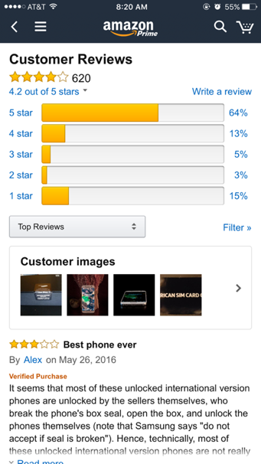 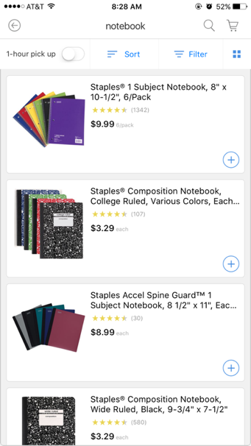 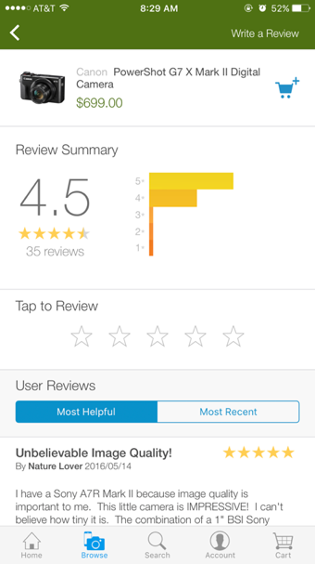 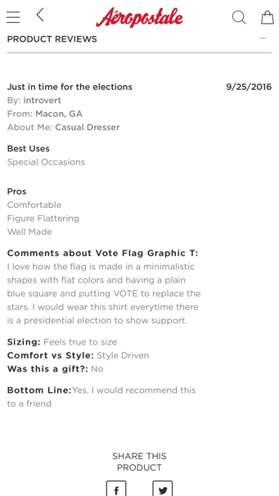

## 4.2. Feature: Bookmarks

**Allows users to save content for future viewing**

**Pros**

* Useful for saving things of interest for quick access in future
* Easily accessible and straight forward to use
* Bookmarked information used for more personalized experience

**Cons**

* Requires a user account
* Users no longer “anonymous”
  + Personal information shared with third-party companies

**Applications Presented**

* TripAdvisor
* Hotels.com
* Hotel Tonight
* Walmart

**Supporting Screenshots**

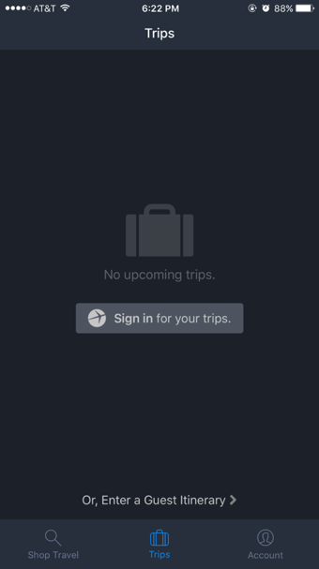  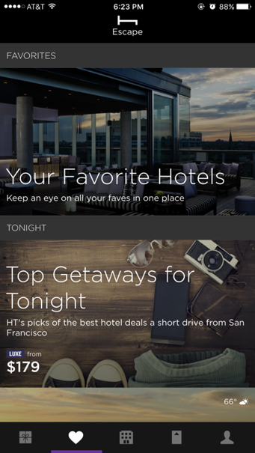 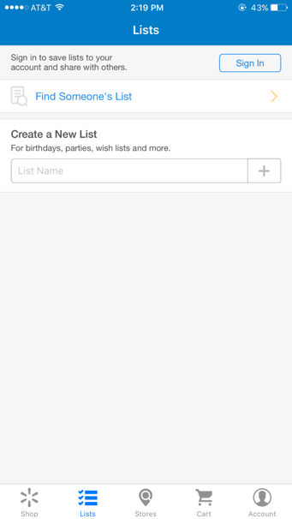

## 4.3. Feature: User Account

**Users can create accounts and log in to the system**

**Pros**

* Having a user account provides extra features
* Mobile applications with web interfaces allows users to use both platforms with ease
* Registration and login process quick and convenient as it’s the first thing users encounter

**Cons**

* Required before users can interact and/or test the application
* Unclear how to skip login and/or registration process
* “Login with your social media account” option a security concern

**Applications Presented:**

* TripAdvisor
* Home Depot
* Lowe’s
* Expedia

**Supporting Screenshots**

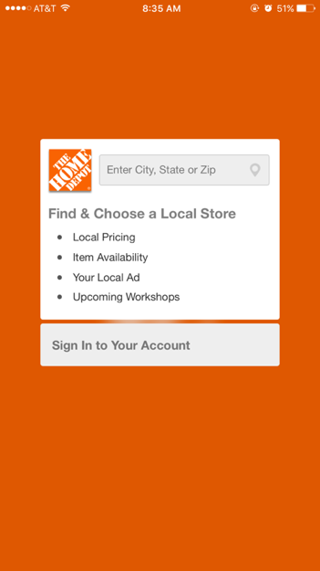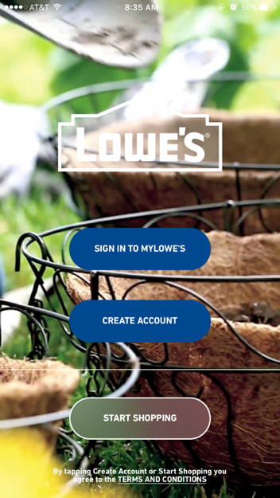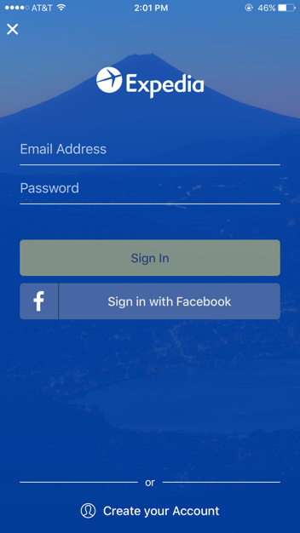

## 4.4. Feature: Advertisements

**Promotes a service, product, or a “thing”**

**Pros**

* User-tailored making it a useful feature for users
* Main source of revenue for applications

**Cons**

* Intrusive
* Takes up a lot of screen real estate
* Difficult to get rid of; no option to do so

**Applications Presented**

* RateMyProfessor
* Fandango
* Cars.com

**Supporting Screenshots**

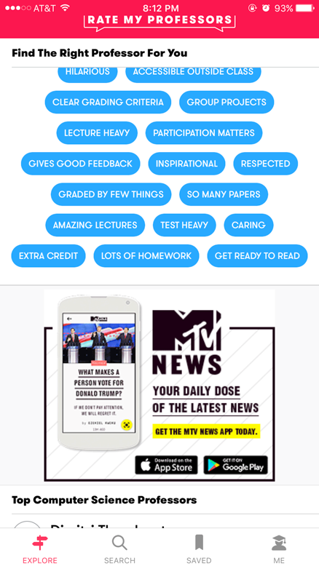

## 4.5. Feature: Recommendations

**Recommends a product, service, or a “thing”**

**Pros**

* Relates to users’ interests
* Allows to “explore more” by showing content that would had been otherwise missed

**Cons**

* Requires users to be logged in
* Requests information about user’s location; security concerns
* Takes up a large amount of screen real estate; becomes annoying for those not interested

**Applications Presented**

* Zappos
* Target
* Yelp
* Macy’s

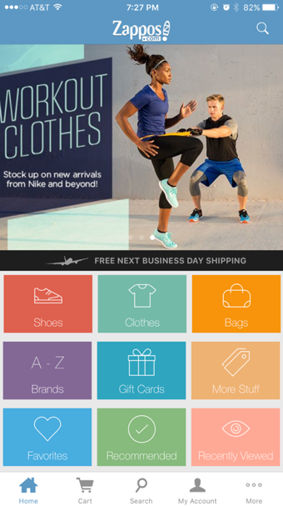  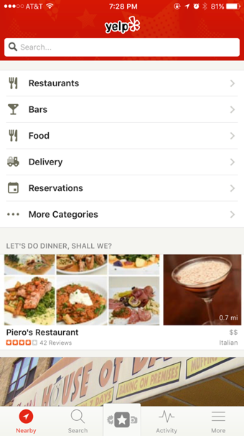 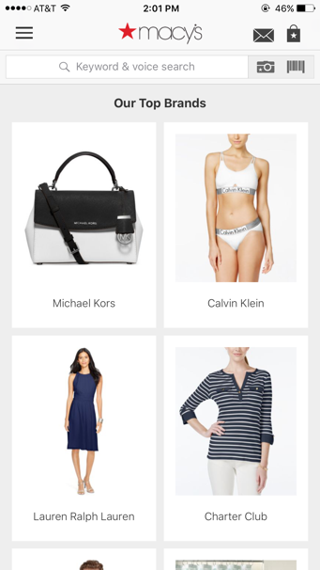

## 4.6. Feature: Search

**Allows to search for things of interest**

**Pros**

* Important feature of recommendation-based application
* Convenient to quickly search for people, products, and/or things with a minimal amount of effort

**Cons**

* Additional content shown upon submitting a search query in form of advertisements
* Irrelevant information shown as the first items of the search result

**Applications Presented**

* eBay
* Yelp
* App Store
* Macy’s

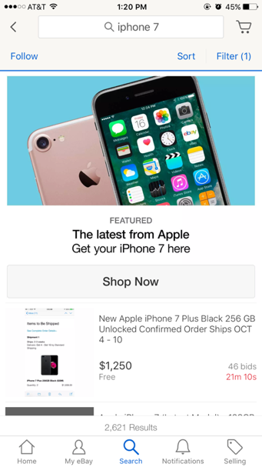 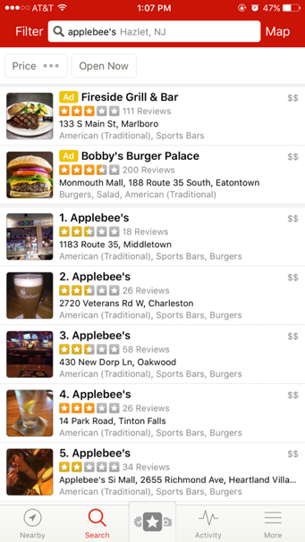 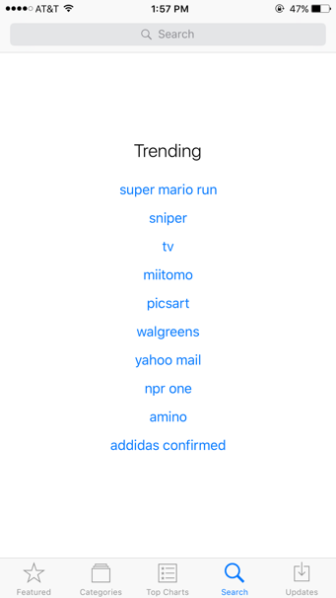 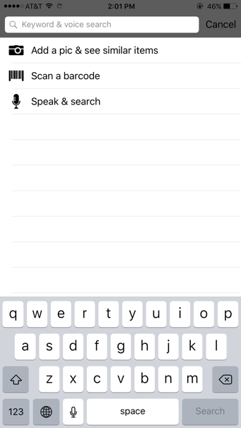

# 5. Personas

## 5.1. Jennifer Edwards – Business Owner

**Background**

Age: **37**

Role: **Business Owner**

Years of Professional Experience: **5**

**Main Points**

* Wants to expand her business
* Wants to target high school and college students with advertisements
* Hasn’t gone on vacation since the opening of her store



Jennifer is an owner of a retail store at a mall in Jersey City, New Jersey, which primary sales shoes and clothing. She has been successfully running her store for the past 3 years, however, recently the sales have declined. Jennifer is aware of online marketing and would like to take advantage of the different means of online advertising, but does not know where to start.

She enjoys being a business owner and she is very proud of that fact. Jennifer appreciates the support from her family and her husband and is very determined to succeed and expand her business to other locations. She dreams of going on a nice vacation, unfortunately, currently Jennifer is very busy with running the store and making sure her business is expanding.

Currently, Jennifer uses her social media accounts to promote her business to strangers. She created accounts on Facebook, Instagram, and Snapchat, however, she does not have a large base of followers on any of these social media platforms, so she needs to find a better way to promote her business.

In her free time, Jennifer likes to spend her time with husband Mark, typically by going to the movies. Mark is a database administrator at Bloomberg in New York City. Even though Mark is busy with his job, he always tries to stop by the store to help Jennifer out however he can.

**Frustrations & Pain Points**

* Sales have decreased over that past couple of months
* Hard to figure out how to effectively market and advertise her business
* Haven’t gone on vacation since opening the store
* Unable to expand her business with current revenue

**Goals**

* Expand her business
* Invest in online marketing to increase sales
* Save enough money for a nice vacation
* Compete with other retail stores

## 5.2. Trevor Crawford – Marketing Analyst

**Main Points**

* Learn more about effective online marketing
* Likes fishing with his friends
* Get promoted
* Target college students with ads & discounts

**Background**

Age: **31**

Role: **Marketing Analyst**

Company: **Best Buy**

Years of Professional Experience: **5**



Trevor is an employee of the marketing department at Best Buy in Richfield, Minnesota. His primary job is to focus on improving sales of products and services. The constant threat of e-commerce sites is driving the sales down so Jim and his colleges have been asked to improve the marketing strategy, with college students and alumni being the primary target demographic.

Trevor enjoys his job and working for Best Buy has taught him a lot. He is very professional and likes to get the job done. Outside of working hours, he likes reading books and researching topics on marketing products and services online. Even though Trevor and his team members are aware of different online marketing techniques, things are changing rapidly and it’s hard to keep up with all new trends.

Trevor realizes the potential for advertisements in mobile applications where college students are the primary target demographic. Having visited websites like RateMyProfessor, his company would want to take advantage of such platforms to better target college students as these are the people likely to buy electronic products from Best Buy.

In his free time, Trevor likes to go fishing with his some of his good friends from high school. He tries to get away at least once every two weeks on weekends to catch up with his friends and what goes on in their life. Trevor is married and a father of two, so he is often very busy and does not like wasting time.

**Frustrations & Pain Points**

* Various e-commerce sites a serious threat to his current employer
* Traditional marketing methods not effective
* Company puts a lot of pressure on him and his team to deliver results
* Online advertisements do not bring the expected results

**Goals**

* Find an effective way to compete with e-commerce sites
* Increase sales of products and services
* Target college students with advertisements & discounts
* Get promoted within the next 8 months

## 5.3. Bob Casey – Assistant Professor

**Main Points**

* Study human behavior and interactions
* Improve his courses and teaching skills
* Wants to be well-known and respected by students

**Background**

Age: **38**

Role: **Assistant Professor at Rutgers**

Department: **Computer Science**

Education: **Ph.D. in CS from MIT**



Bob is an assistant professor at Rutgers in New Brunswick, NJ. Most of his time is spent on research related to big data where he focuses on human behavior and interactions. He enjoys doing research and teaching graduate courses in the meantime. Bob is always looking to improve, whether it’s in his professional or personal life, which is why he spends a lot of his free time reading books related to human interaction and technology.

Although Bob has only been teaching graduate courses for a short amount of time, he has a decent reputation amongst students.

Bob always looks for improvement, which is why at the end of the semester he asks his students for a short feedback about how he can improve his courses, as well as his teaching. He likes to make the class entertaining but also challenging.

Bob tries to make his courses heavy on programming assignments. He believes programming is a very valuable skill to have nowadays and tries to make his programming assignments challenging but fair. Taking into consideration the fact that not all students are on the same technical expertise level, Bob stays after class to help his students with any issues they may have.

Bob’s aware of system such as RateMyProfessor and even though the CS department at the school he teaches asks students to complete course evaluations, these are only available to the school and himself. He’s also aware that many students will first try to get some information about him on RateMyProfessor before registering for his courses. Bob believes that students should have the right to know some details about professors before registering for classes, however, he does not think the information available on RateMyProfessor is sufficient for making these types of decisions, and is also not helpful to Bob himself, as the feedback he gets is often not relevant and presents only the extreme cases.

**Frustrations & Pain Points**

* Research takes up a lot of his time
* Hard to keep up with grading assignments
* Does not agree with some of negative feedback he gets from students on RateMyProfessor
* Hard to improve his teaching when rated on irrelevant information

**Goals**

* Learn more about human behavior and interactions
* Get feedback on his teaching so that he can improve
* Reward students with “recommendations” to motivate them
* Be well-known and respected by students
* Have good ratings on professors’ recommendations apps

## 5.4. Jake Simpson – Graduate Student



**Background**

Age: **24**

Role: **Graduate Student**

Field of Study: **CS**

Education: **B.S. in CS from NJIT**

Level of Computer Expertise: **Advanced**

**Goals**

* Improve his programming skills
* Learn more about software development
* Find reliable information about classmates’ performance in group projects
* Avoid courses with group projects

**Frustrations & Pain Points**

* Unable to find any relevant information about his classmates
* Doesn’t like working with people that show lack of effort or care
* Current job is not as flexible with his school schedule as he wishes

**Main Points**

* Learn about software development
* Avoid group projects at school
* Impress his current employer with his technical expertise
* Stay on top of his work

Jake is a 2nd year graduate student at New Jersey Institute of Technology majoring in Computer Science. Although he’s a part-time student, he works full-time for Audible in Newark, New Jersey. At Audible, he is a part of a small team of 4 responsible for major components of the Audible mobile application.

Jake decided to go back to school to learn more about software development and improve his programming and problem solving skills. He very much enjoys building software and playing around with web technologies. In his free time, he tries to contribute to open source software because he believes it makes him a better software engineer. Jake also enjoys hiking and different physical activities. On weekends, he goes to local meetups for mobile developers to meet new people and network.

Although Jake doesn’t mind working on various projects with a group of people, he doesn’t quite enjoy the work he gets assigned in the classes he takes. Particularly, he does not like group projects where people tend to slack and show lack of effort when it comes to getting things done. He tries to avoid classes with group projects at all costs.

Jake is a pretty busy person and tries to stay on top of his work when it comes to both school and work. He does not like waiting until the last minute to submit his work and likes to be ahead of the schedule so that if something unexpected comes up, he doesn’t have to stress over it, but rather tackle it peacefully.

## 5.5. Blake Reed – Graduate Student



Blake is currently a 1st year graduate student at New York University. He received his bachelor of science degree in Information Systems from New York University and he decided to continue his education at the institution. Blake very much enjoys going to school and he believes education is important.

Due to increase of cybercrime over the recent years, Blake has decided to learn more about cyber security. His goal is to work as a cyber security analyst in New York City so that he can help others protect their private data. Blake has always been the “techie” guy and he’s been playing with computer since the early age. As soon as he bought his first computer, he started learning about programming and backend security.

Blake is currently married and has two kids, a 2-year old and a 5-year old. He likes to stay busy and spend time with his family. Blake is currently a full-time employee at Citigroup in New York City and is part of the IT department.

Due to his busy life, Blake is a part-time student at NYU and tries to take no more than 2 classes per semester. He prefers online classes; however, he lives close to the campus, and his employer is also flexible with his school schedule and lets him leave early to class if necessary.

To help him pick his classes, he uses RateMyProfessor, which is a rating system for professors that also provides some information about the courses a professor teaches. He finds the system to be unreliable and often does not find the information he’s looking for. Blake wants to make sure that his courses are related to cyber security and his professors are experience in the field, however, it is often difficult for Blake to find any such information, and he’s left with no other choice then register for the course and hope for the best.

**Goals**

* Wants to help fight cyber crime
* Find information about courses and professors
* Finish the graduate school by the end of year 2017
* Learn more about cyber security and improve his technical skills

**Frustrations & Pain Points**

* Unable to find reliable information about professors and courses
* Current rating system for professors requires him to register a new account
* Believes current rating system has authenticity issues
* Unable to find professors that have the expertise in cyber security

**Main Points**

* Wants to learn about cyber security
* Full-time employee at Citigroup
* Part-time graduate student at NYU
* Prefers to take his classes related to cyber security

**Background**

Age: **29**

Role: **Graduate Student**

Field of Study: **IS**

Education: **B.S. in IS from NYU**

Level of Computer Expertise: **Advanced**

## 5.6. Mark Ruffalo – Graduate Student



**Frustrations & Pain Points**

* Hard to find relevant information about professors and their courses
* Hard to keep up with homework assignments when he works full-time
* Always stays busy and it’s hard for him to find some free time

**Goals**

* Move up within his company
* Earn an MBA degree with a high GPA
* Find information about professors
* Get information about classes for professors he’s interested in

**Background**

Age: **35**

Role: **Graduate Student**

Field of Study: **CS**

Company: **Cognizant Technologies**

Position: **Senior Associate**

Level of Computer Expertise: **Advanced**

**Main Points**

* Works full-time
* Wants to improve his business & management skills
* Receive an MBA and move up the ladder at his current job
* Plans to join NJIT as a part-time student

Mark is a full-time employee at Cognizant Technologies. He is currently a senior associate, but he would like to move up the ranks, and in order to do that, he needs to earn an MBA degree. He is married and has two children that are currently in high school.

He hasn’t been quite satisfied with the current position at his job he occupies and he wants to get promoted so that he can earn more money and start enjoying working again. He decided to join the MBA program as a part-time student at NJIT. Since Mark is working full-time, he would prefer to take some of his classes online and some on campus.

Mark is interested in finding information about professors and their courses he might be interested in taking. He’s pretty busy with work and his family, so he tries to find professors with specific characteristics so that he doesn’t have to stress too much about school on top of other things he needs to take care of. He has not been quite successful finding relevant information about professors and their classes and he starts to get a little frustrated and anxious, thinking that he won’t be able to do well in with his degree.

Aside from working full-time and pursing an MBA degree in Business & Management, Mark likes spending his time with his friends and family whenever he can. He enjoys sports and on weekends tries to meet up with his friends to play a little game of football. His kids are also big fans of football, so he tries to take them to football games on weekends whenever he gets a chance.

## 5.7. Rich Anderson – Business Owner



**Main Points**

* Increasing revenue for his business
* Help transitioning into the online market

**Background**

Age: **56**

Role: **Businessman**

Field of Study: **Business**

Education: **MBA Harvard Business School**

Level of Computer Expertise: **Intermediate**

**Goals**

* Re-establish a customer base via advertising
* Add value to existing business model if possible
* Create new business networks and track product milestones

Rich is an ivy-league educated businessman with deep roots in small business management specializing in athletic clothing and equipment. His background includes an MBA from Harvard Business School and a Masters in Economics. During college, he worked in a corporate sporting goods stored name Port Authority which sold aquamarine products. After graduating and learning about sales, product management, competition and customer service, Rich decided to take a small loan and start his own company.

Rich loves sports, so he wants to sell sports products. He started Rich’s Sporting Goods in 1999 in New Jersey with one store and by 2007 expanded with 22 stores throughout the east coast from Pennsylvania to Florida. As of 2016, Rich has 134 stores in more than 12 states. A married father of five, Rich maintains a very busy schedule working 40-50 hours per week. He has a corporation to manage, a family to look after, not to mention his own well-being.

Recently, Rich has seen a decline in sales for some of his stores across the country and he needs to act quickly. The emergence of online advertisements and e-commerce have been the primary factor behind declines in sales for Rich’s stores. Rich’s goals are to transition into e-commerce and find applications he can advertise from toward his target audience. His target audience are ages between 10 and 25.

In his free time, Rich likes to spend his time with family by taking trips to different places every 6 months. Due to his busy life, he doesn’t get to spend as much time with his family as he would like to, so he feels obligated to take a short vacation every now and just so he can take his family somewhere nice and spend some time with them.

**Frustrations & Pain Points**

* Poor retail sales
* Growing his business online
* Very high expanses

# 6. Problem Scenarios

## 6.1. Jennifer Edwards – Business Owner – Advertise Her Business

****Jennifer is an owner of a retail store at a mall in Jersey City, NJ, where she primarily sells shoes and clothing. She’s been able to successfully run the store for the past 3 years, however, recently the sales have declined. It is very difficult for Jennifer to keep up with online retailers and it’s hard to compete with e-commerce giants such as Amazon or Zappos. She is aware that technology is the primary drive behind her recent problems since people are more likely to purchase goods online rather than coming to a mall or shopping at a local store.

Jennifer has been putting a lot of effort in her retail store to make sure it grows steadily so that she can expand her business to more locations. She dreams of opening a store in the center of New York City, however, with how things are going now, she will not be able to achieve this goal. Jennifer works hard to make sure her business keeps growing, so she started researching about different ways to advertise her business online.

While searching the internet for different online marketing strategies, she realizes that mobile applications and social media are a great way to target new audience. Jennifer has tried to create social media accounts on Facebook, Twitter, and Instagram to promote her business, however, with the small number of followers, she quickly realized that it’s not so effective. She even tried to tell her relatives and friends to share the links to her business’ social media accounts, but she did not gain that many new followers.

Since Jennifer’s store primarily targets high school and college students, she wants to be able to find an application that will target either of these two group of students. She does believe, however, that college students will be more likely to come to her store and buy clothes or shoes as these are usually the people that are working and supporting themselves.

Social media is very big nowadays, but it’s hard to gain a lot of followers unless you constantly post interesting content so that followers can think it’s worth sharing with others. Jennifer is the only person responsible for running her social media accounts, but she does not have experience in this field. She does not how to effectively use social media to target potential customers, and she would be willing to explore other means of online advertising, preferably something that targets college students and has a greater exposure to more potential customers.

### 6.1.1. Jennifer Edwards – Business Owner – Storyboard

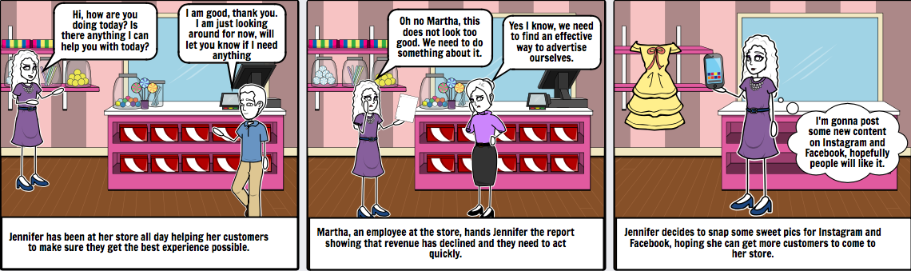

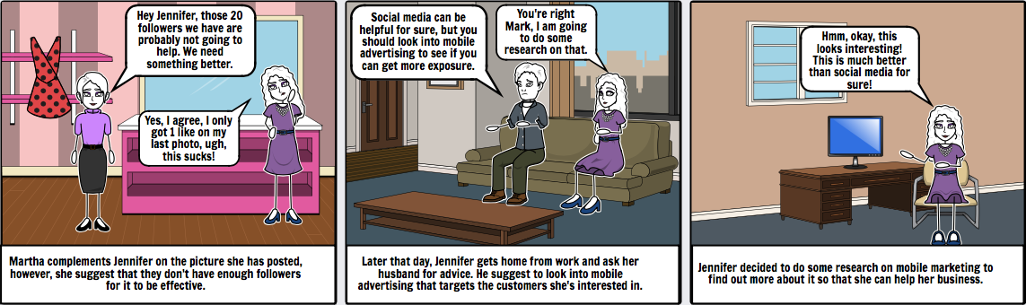

## 6.2. Trevor Crawford – Market Analyst – Compete with Giant Ecommerce Sites

****Trevor is currently an employee of the marketing department at Best Buy in Richfield, Minnesota. His primary job is to focus on improving sales of products and services. The constant threat of e-commerce sites is driving the sales down so Jim and his college are constantly at work trying to improve Best Buy’s marketing strategy. The company wants to target college students because they believe that these are the type of people that are more likely to buy electronic products and user Best Buy’s various services.

Trevor enjoys what he does and likes working for Best Buy. He likes that he gets to meet a lot of new people and is constantly working on solving different problems. With rapid changes in technology, Jake is fully aware of the constant threat from e-commerce sites and he wants to find different ways on how to compete with giant online retailers like Amazon or eBay.

Outside of work, he typically spends 1-2 hours a day researching about online marketing and tries to explore different ways that he can target more customers and bring more revenue to his company. Best Buy and its marketing strategies have used online advertising to try to expose themselves to a greater number of customers, however, they still find hard to compete with online retailers. Jake was the one responsible for proposing to start targeting customers with Google’s AdWords, which has worked wonderfully for over a year, but hasn’t been much of a help in the recent months.

Jake is aware of the advancements in mobile application development and believes that mobile advertisement is the next big thing when it comes to online advertising, so he started exploring different ways of how he can incorporate mobile applications in his marketing strategy. Jake is aware of social media platform such as Snapchat and Instagram, but the variety of users using such applications is tremendous that it is hard to target a target demographic, such as college students.

Also, there is currently no way to provide something more than just advertisements to users of Snapchat or Instagram. Jake and his team are open to an idea where users are shown advertisements in form of coupons that they can redeem at a local Best Buy store or their website. He knows that showing advertisements will not be affective because this is something they have tried and it’s still to compete with giant online retailers. However, Jake thinks providing rewarding active users with coupons or discounts will give the user a reason to buy their next product at Best Buy rather than from competitors.

### 6.2.1. Trevor Crawford – Storyboard

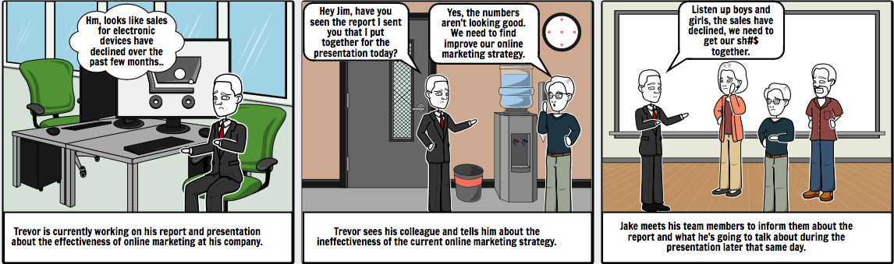

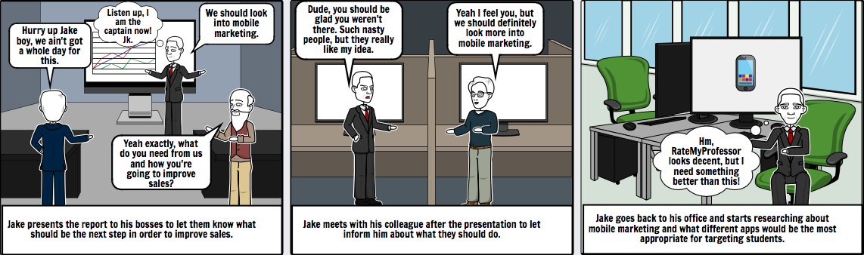

## 6.3. Bob Casey – Assistant Professor – Get Meaningful Feedback



Bob is an assistant professor at Rutgers University in New Brunswick, New Jersey. Most of his time is spent on research related to big data where he focuses on human behavior and interactions. He enjoys doing research and teaching graduate courses in the meantime. Bob always looks to improve, whether it’s in his professional or private life, which is why he spends a lot of his free time researching about human interactions, technology, and how to effectively teach difficult material by making it interesting and challenging.

Bob has been teaching courses at Rutgers University for a short amount of time, however, he’s been able to get a decent reputation amongst students. Many of his previous students think that Bob’s way of teaching is very engaging and they learn a lot from his lectures. Since Bob has only been teaching graduate courses for less than 2 years, he deeply cares about the feedback he gets from his students, whether it’s from the course evaluations at the end of the semester or other sources, such as RateMyProfessor.

Even though course evaluations are available to Bob, he does not think it’s fair that this information is hidden from his potential students. Bob is aware that he is free to post this information on his website, however, he doesn’t think that it reaches the number of people that he wishes it did. Students are often confused and undecided on which professor to take, making Bob seem like a “hard” professor and someone to avoid.

Bob often checks his profile page on RateMyProfessor to see what kind of feedback he gets. Primarily it’s because to make sure that the feedback others see about him will not affect the enrollment in a negative way. But as mentioned previously, Bob also likes to improve, so he’s more interested in how he can improve his courses so that people can learn more effectively and enjoy his classes so that they come back next semester.

Unfortunately, RateMyProfessor does not provide any relevant information that Bob can use, and he is often left with little to no information on how he can improve his courses. Bob decided to have a short questionnaire at the end of the semester for each of his classes where he asks students about things that could be improved or would like to be introduced as part of the course. However, since the short questionnaires are done during the last week of classes, he realizes that students tend to get sick of more school work at that point and don’t take this form of feedback seriously. Bob wishes that RateMyProfessor would provide more relevant information about the course and his way of teaching, rather than short comments, often related to course work.

### 6.3.1. Bob Casey – Storyboard

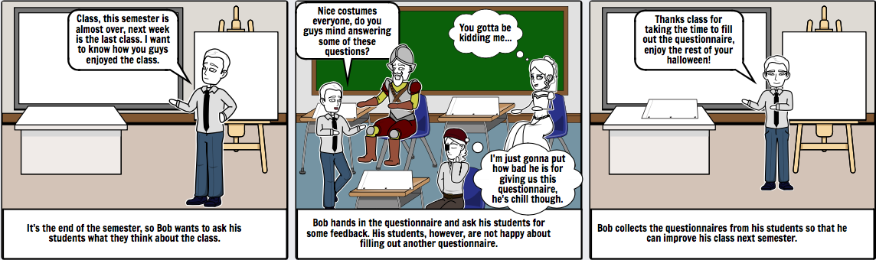

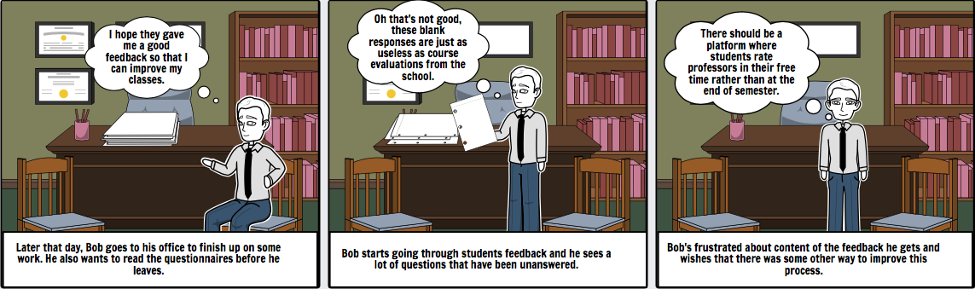

## 6.4. Jake Simpson – Graduate Student – Find Reliable Group Members

****Jake is a second-year graduate student at New Jersey Institute of Technology majoring in Computer Science. He works as a software developer at Audible and has been with the company for the past 3 years. While at Audible, he got involved with multiple project and he’s been a part of a small team of 4 responsible for maintaining some of the functionality of the Audible application. Jake’s primary role is to make sure that the search feature works flawlessly and delivers the most accurate results.

While at Amazon, Jake learned that having skilled and highly motivated group member is a key to success. He enjoys working with people that are very knowledgeable in their respective fields because he tends to learn a lot from them.

Being a part time graduate student at NJIT and working full-time at Audible, Jake is a busy person but strives to stay on top of his work. He doesn’t like to slack and constantly wants to improve. Some of the people he has met in school have become his friends and he values the experience he gets while being an NJIT student. Jake is always eager to learn about software development, and technology in general, but he likes the fact that he can meet so many different people and learn something from all of them.

Although Jake likes going to school in general, he prefers for his teachers to assign individual assignments, rather than group projects. One of the main frustration for Jake is the poor experience he has had so far in his graduate courses. All the courses he has taken so far required group projects, which are a big part of the final grade. In his professional career, he enjoys working with skilled and highly motivated people. However, Jake quickly learns that his is not always the case when it comes to the courses that he takes.

Many of the group member he’s worked with on various group projects while in the graduate school are slacking and not doing what they are supposed to. Jakes gets frustrated because he works full-time and takes his job seriously. He does not want to do the extra work when he’s busy making deadlines for his job. Currently, he relies on LinkedIn and Facebook to get information about his classmates and/or group members, but he does not think this is an effective way of getting information about someone. Neither LinkedIn nor Facebook has been very helpful for Jake so far, and he wishes he had the ability to get information about his classmates from other sources. It’s very hard for Jake to figure out who is going to contribute to group projects as semester progresses.

### 6.4.1. Jake Simpson – Storyboard

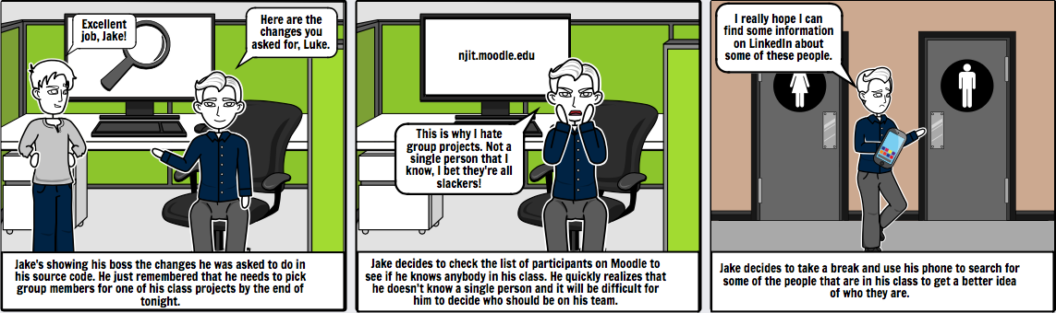

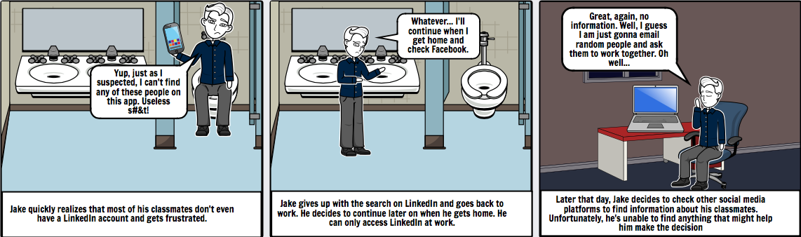

## 6.5. Blake Reed – Graduate Student – Get Information About Professors & Classes



Blake is currently a first-year graduate student at New York University. He received his bachelor of science degree in Information Systems from New York University and he decided to continue his education at the same exact institution. Blake very much enjoys going to school and believes that education and constant improvement are very important. He is currently a full-time employee at Citigroup in New York City and enjoys working as an IT specialist.

Due to increase of cybercrime over the recent years, Blake has decided to learn more about cyber security so that he can help others protect their personal data. His goal is to work as a cyber security analyst in New York City and continue improving his technical skills. Blake has always been the “techie” guy and you’d often see him play with computers since the early age.

So far, Blake enjoys the experience of being a graduate student at NYU. He is a part-time student as he works full-time, but still enjoys staying busy, learning new things, and meeting new people both at work and in school. He does not have any major complaints about the classes and professor he has taken, however, he’s at a point in his career where he would like to focus on cyber security rather than learning things that are not of his interest.

Jake wants to get information about classes and professors he’s planning on taking. He is fully aware of course evaluations being done at the end of semester for each class at NYU, however, this information is not fully accessible to students, only the school itself and its professors can see it. Jake is fully aware of websites such as RateMyProfessor, but they don’t provide enough information about the class or professor of his interest. As a matter of fact, he has a hard time believing what others have posted on the platform, and he does not take these reviews seriously.

It’s hard for Jake to find reliable information about courses and professors. While at NYU, he has met many people and became friends with some of them. Whenever he needs to register for next semester, he relies on his friends from school whenever he wants to find out about a course or professor. Unfortunately, he does not always get what he’s looking for, and often his friends don’t have any information about the course or professor of his interest, leaving him contemplating whether he should register for the course or not. Jake wants to be able to find a reliable source of information that he can trust, so he can pick the appropriate classes with professors that are knowledgeable in cybersecurity so that he can learn more about Internet security and reach his goal of being a cyber security analyst.

### 6.5.1. Blake Reed – Storyboard

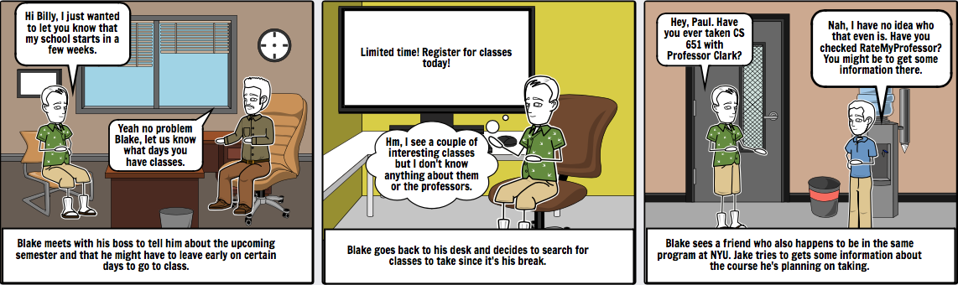

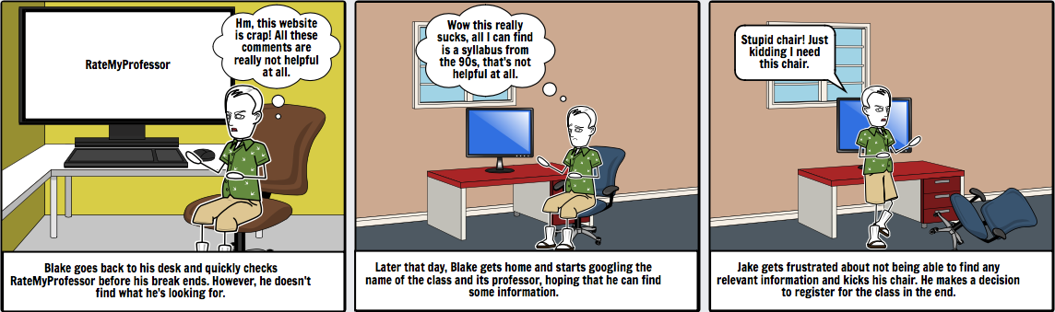

## 6.6. Mark Ruffalo – Graduate Student – Get Information About Professors & Classes

Mark is a full-time employee at Cognizant Technologies and he has decided to go back to school to earn an MBA degree so that he can get promoted at his job. His current position is senior associate, but he doesn’t quite find joy in what his doing at the moment and would like to try something new. He decided to join NJIT as a part-time graduate student and as the new semester is approaching, he needs to quickly figure out which classes he should take.

Because Mark is a pretty busy person, working full-time and taking care of his wife and two children, he looks for specific professors and classes so that he can manage the workload that he will need to deal with once he starts school. Because his time is limited, he doesn’t want to spend a lot of time on homework, and he would prefer to take classes that are not as heavy on homework assignments. Mark would also prefer taking his classes under professors that are knowledgeable in the course material so that he can learn the most that he can.

He has a few friends that are also going to NJIT so he tried getting some information from them about professors and classes. Unfortunately, the information that Mark has been able to get from his friends hasn’t been quite useful, with some recommending Mark to check out RateMyProfessor for reviews about classes and professors. Unfortunately, some of the information that he is interested in was missing from that website and it hasn’t really helped him make the decision on which classes and professors he should take.

Mark has even tried getting help from an advisors, however, it’s been very difficult for him to schedule an appointment that’s convenient from him because it conflicts with his busy schedule. Since talking to his advisor is almost an impossible task, he would like to use an alternative method that’s much simpler than what he has to go through now to get some information about classes and professors.

As previously mentioned, he’s looking for professors that are knowledgeable in the course content they teach. It’s important for Mark to be able to have a clear understanding of what’s going on in class due to the limited time he has. He wants to make sure that none of his questions will go unanswered and he would feel more comfortable taking a class under a professor that he can rely on. Mark’s also interested in courses that are not so heavy on homework assignments. He would, however, prefer working on group projects, as it’s something he deals with on a daily basis and he feels more comfortable doing that. It’s quite difficult for Mark to get the information he’s looking for and he wishes there was a better and more reliable way to get this information.

### 6.6.1. Mark Ruffalo – Storyboard

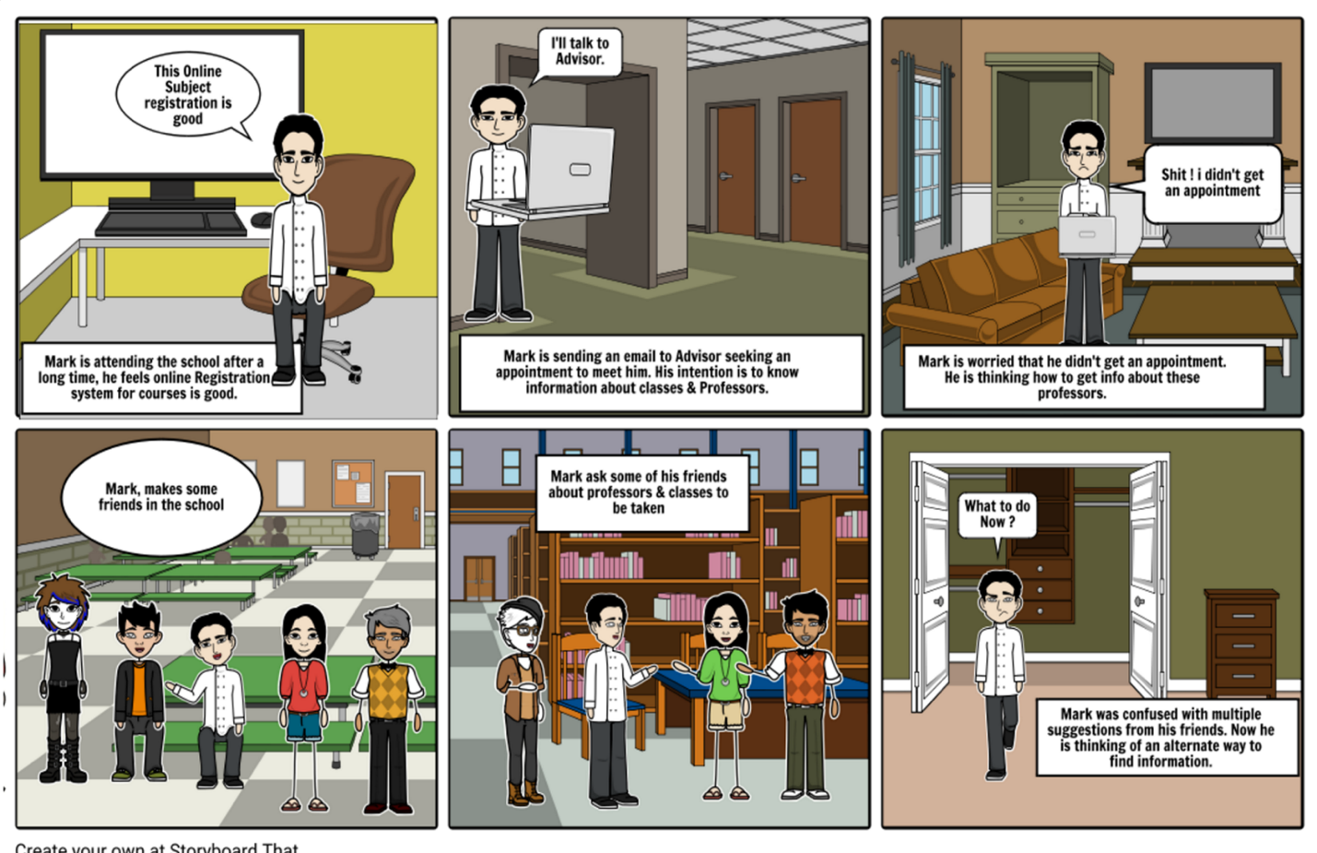

## 6.7. Rich Anderson – Business Owner – Take Advantage of Mobile Marketing

Rich is an ivy-league educated businessman with deep roots in small business management specializing in athletic clothing and equipment. His background includes an MBA from Harvard Business School and a Masters in Economics. Rich loves sports, so he wants to sell sports products. He started Rich’s Sporting Goods in 1999 in New Jersey with one store and by 2007 expanded with 22 stores through the east coast from Pennsylvania to Florida. As of 2016, Rich has 134 stores in more than 12 states.

In the recent months, however, Rich has struggled to keep his ‘brick-and-mortar’ shops afloat. Taxes, property leases and employee salaries are eating up his revenue. Rich feels transitioning to online will reduce his expenses substantially.

Rich has tried many ways such as mail advertising, coupons in store and rebates to keep his customers, but starts to see a decline in revenue. Venturing to expand his business networks into e-commerce, Rich is actively looking for a better way to advertise his products online. He is not technologically savvy as he has only used forums and the Internet. Rich wants to start to use the Internet to advertise his products and business online where he can target high school and college students because most of the products he makes are used by this target audience.

In recent years, the emergence of e-commerce, web and mobile advertising have been the primary factor behind the decline of sales for Rich’s stores. He knows that in order to stay competitive and keep his stores open, he needs to invest some of his marketing money into online advertisements. Rich has done some research to learn about mobile advertising, which allows business owners to pay application development companies to display ads on their apps.

According to the information Rich has been able to obtain, mobile advertisements are useful and effective for targeting a specific audience. In Rich’s case, he is primarily interested in targeting high school and college students because most of the products he sells are used by this target audience. Currently, Rich is looking for a mobile application that he could use to target high school and college students around the country to help him increase sales and keep his stores open.

### 6.7.1. Rich Anderson – Storyboard

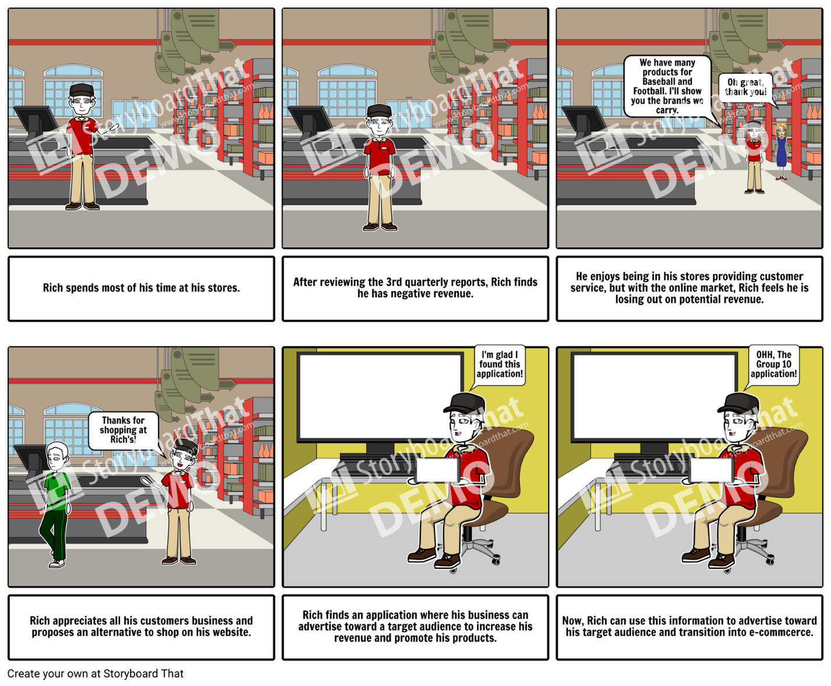

# 7. Activity Scenarios

## 7.1. Jake Simpson – Find Reliable Group Members – Best Case Scenario

****Jake has very much enjoyed the winter break and having some time off from school. Jake is aware that the Spring semester is approaching very quickly as he has been getting emails from his professors with syllabuses and other information related to courses he’s planning on taking. Having a brief look at some of the information shared by his professors, he noticed that nearly all his courses require some sort of group assignments. Jake hates group assignments as he’s almost never able to find reliable group members and typically doesn’t know anyone in his classes.

Jake decides to use this new app that allows college students to rate classmates based on group performance so that others can make more informed decisions when determining who should they work with on the next group project. Jake’s primarily looking for people that finish their tasks on time and do a good job. Although he doesn’t look for any specific field of interest that a person may have, he would prefer working with someone that likes programming or is a software developer. Jake is a software developer himself, so he feels like he would be more connected with other fellow software developers.

Fortunately for Jake, his school provides a list of participants for every class he takes. Jake’s initial reaction to the information he finds about some of his classmates on the app is positive. He’s able to get some general information about the performance of his classmates when it comes to group projects. He does pay a close attention to people that produce quality work and are on time with their tasks.

Since the group project allows a maximum of 4 people, he identifies 3 people that he would be interested in forming a group with. All those classmates had at least 8 or more decent reviews and some of them were recent. They all had good ratings when it came to quality of work produced and being on schedule. Although these reviews looked to be anonymous, they were consistent, which has made Jake believe this information is most likely honest and it’s something that it wouldn’t hurt to trust. He likes the fact that the reviews are split into different categories, such as whether the person attends group meetings regularly, contributes to the group, or completes his/her tasks on time. Jake’s able to quickly identify the attributes he’s looking for, making his decision making more efficient.

Jake feels confident about the information he could gather after using the app and decides to shoot an email to all those classmates that he would like to form a group with. He quickly gets a response saying that they are willing to work with Jake on the group project.

### 7.1.1. Jake Simpson – Storyboard

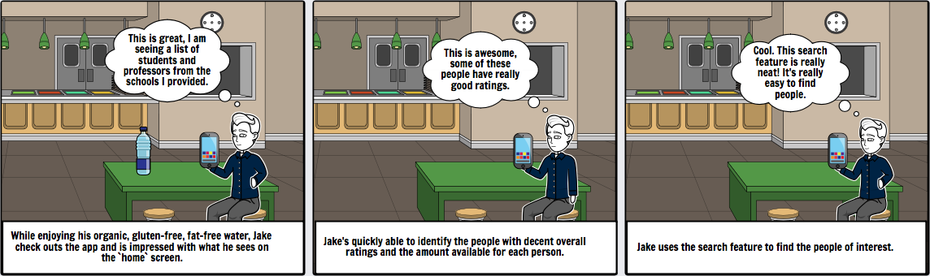

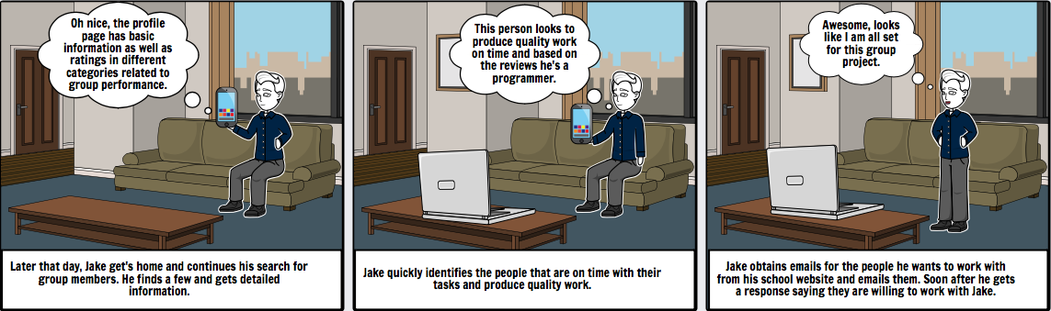

## 7.2. Jake Simpson – Find Reliable Group Members – Worst Case Scenario

****Jake has very much enjoyed the winter break and having some time off from school. Jake is aware that the Spring semester is approaching very quickly as he has been getting emails from his professors with syllabuses and other information related to courses he’s planning on taking. Having a brief look at some of the information shared by his professors, he noticed that nearly all his courses require some sort of group assignments. Jake hates group assignments as he’s almost never able to find reliable group members and typically doesn’t know anyone in his classes.

Jake decides to use this new app that allows college students to rate classmates based on group performance so that others can make more informed decisions when determining who should they work with on the next group project. Jake’s primarily looking for people that finish their tasks on time and do a good job. Although he doesn’t look for any specific field of interest that a person may have, he would prefer working with someone that likes programming or is a software developer. Jake is a software developer himself, so he feels like he would be more connected with other fellow software developers.

Fortunately for Jake, his school provides a list of participation for every class he takes. Jake’s initial reaction to the information he finds about some of his classmates on the app is okay. He’s able to get some general information about the performance of his classmates when it comes to group projects, however, some of the information wasn’t as detailed as he would like it to be. Jake’s primary looking for students that can produce quality work on time. However, he notices some of the people he could find on the app aren’t rated in this category. The app allows reviewers to provide information based on different criteria, but it looks like the characteristics valued by Jake have been omitted by most reviewers.

Jake is having mixed feelings about the information that he gets, however, he notices that some of the categories that reviewers get to provide their feedback on are mandatory and cannot be omitted. Two of them rate students based on whether they demonstrate a cooperative and supportive attitude and whether they contribute meaningfully to group discussions. Even though these characteristics are of lesser importance, he could still use that information to help him make a more informed decision.

Jake’s options have expanded due to the missing information he was interested in; however, he is still able to get a good idea of who should be in his group. He could find some decent reviews on a few of his classmates, which also suggested that these people are good at participating in group discussions and showing a cooperative and supportive attitude. Jake decides to contact those classmates and the next day he gets a response saying that they are willing to work with Jake on the group project.

# 8. Information Scenario

## 8.1. Jake Simpson – Find Reliable Group Members

Jake is aware that the Spring semester is approaching very quickly as he has been getting emails from his professors with syllabuses and other information related to courses he’s taking. He noticed that nearly all his courses require some sort of group assignments. Jake hates group assignments as he’s never able to find reliable group members. Jake decides to use this new app that allows college students to rate classmates based on group performance.

Jake’s interested in people that can finish their tasks on time and produce quality work. Although he doesn’t look for any specific field of interest that a person may have, he would prefer working with someone that likes programming or is a software developer. Jake’s a software developer himself, so he feels that he would be more connected with other fellow software developers.

Fortunately for Jake, his school allows him to get a list of participants from one of the systems the school provides for submitting assignments and getting course material for his classes. Jake’s able to quickly identify who is in his classes and start searching some names in the app. Jake remembers that upon registration, the app has asked him to fill out a form with his personal information which included the list of school(s) he’s currently attending. Jake likes the fact that the `Search` screen shows him a list of students and professors from the school he has chosen upon registration instead of filtering through a large amount of search results. He realizes that for each person he searches for, he’s able to quickly identify the overall rating and the amount of ratings an individual may have. All this information is available to Jake because of other students’ feedback that was provided on their own free will.

Jake starts to type in some names in the search bar on the `Search` screen and is quickly able to find the people he’s looking for. At a first glance, they appear to have good amount of ratings with decent overall ratings so he decides to look at their profiles to get more information about them. Jake’s presented with general information about his classmates along with their majors and schools that they have attended. He notices that each profile also has an email address of the individual, which allows him to quickly confirm this person is in fact going to the same school as Jake. The reviewers’ have also provided information related to group performance in form of ratings related to overall contribution to the project, cooperation, and other categories.

Jake sees that the people he identified have decent overall ratings, however the ratings in the “Completes Tasks on Time” and “Quality of Completed Work” categories are missing. The ones that are not missing rate students based on whether they demonstrate a cooperative and supportive attitude and if they contribute meaningfully to group discussions. Even though these characteristics are of lesser importance, Jake’s still able to use that information to make his decision.

Jake continues going through those individuals’ profiles and notices a tab which allows him to see additional information in form of comments that reviewers had provided about those individuals. This allows him to quickly get more information that may had been left out from the “aggregate ratings” section. He likes the fact that each individual comment/rating has a section which states whether the reviewer recommends the individual or not.

Jake has picked potential group members that had good overall ratings and high ratings when it came to demonstrating a cooperative and supportive attitude and contributing to group discussions. He gets their emails from the profiles provided in the app and decides to contact them. The next day, Jake gets a response from them saying that they are willing to work with Jake.

# 9. Key Path Scenario

**The key path scenario(s)/prototype can be viewed here:**

* <https://web.njit.edu/~tg77/is661/dist/key-path-scenario/>

## 9.1. Jake Simpson – Find Reliable Group Members

Jake Simpson, a graduate student at New Jersey Institute of Technology, wants to find reliable group members that he can work with on a group project for one of his classes he’s taking in the upcoming semester. He cares about information related to group projects and he’s particularly looking for people that have high ratings when it comes to the quality of work produced and whether they are on schedule with assigned tasks.

To help Jake with his decision making, we’ve introduced a set of different categories/characteristics in which reviewers can rate their classmates. This helps Jake to quickly identify a different set of characteristics and/or the strong points of that individual. Additional information that Jake may encounter while looking through those individuals’ profiles is irrelevant to his initial goal, however, it’s still applicable as Jake might find this information to be useful as well. Below are the steps that Jake would take to find the information he’s interested in.

**Step 1:** Go to the **`Search`** screen and type in the name of the student in the search bar, for example, **`Randall Rivera`** - see **Figure 1** below for details

**Step 2:** Click on the appropriate student to get more information about him/her – see **Figure 2** below for details

**Step 3:** Scroll down in the **`Overview`** tab to get information about the student as well as his/her aggregate ratings – see **Figure 3** below for details

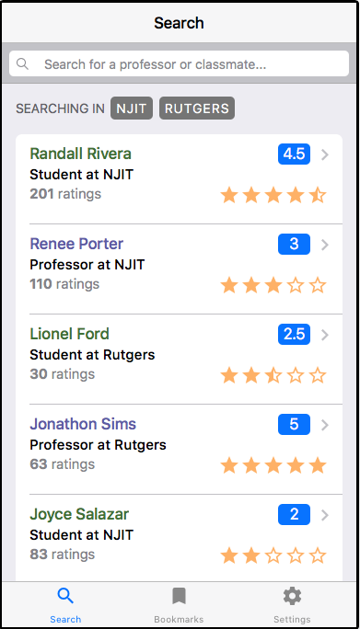 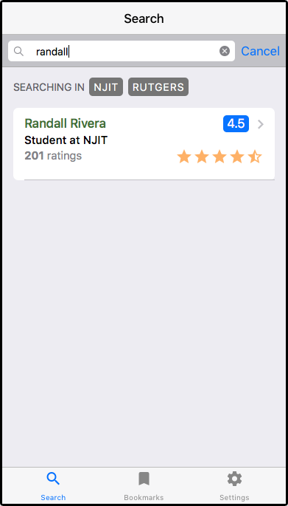 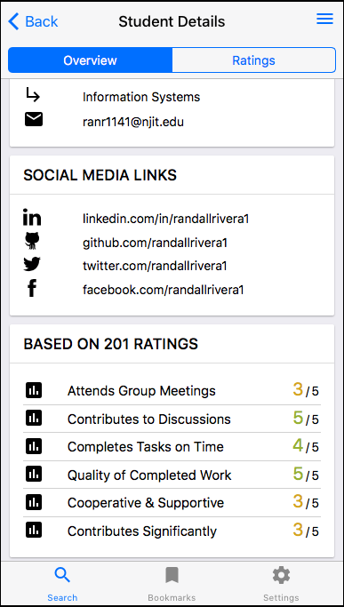

***Figure 1 Figure 2 Figure 3***

**Step 4:** Press the **`Ratings`** tab to see comments and ratings provided individually by classmates of the student – see **Figure 4** below for details

**Step 5:** Press the **`arrow down`** icon next to the **`I would recommend this student!`** to get detailed information about a particular rating – see **Figure 5** below for details

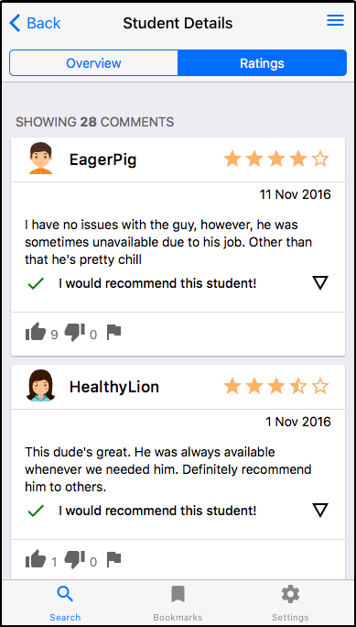 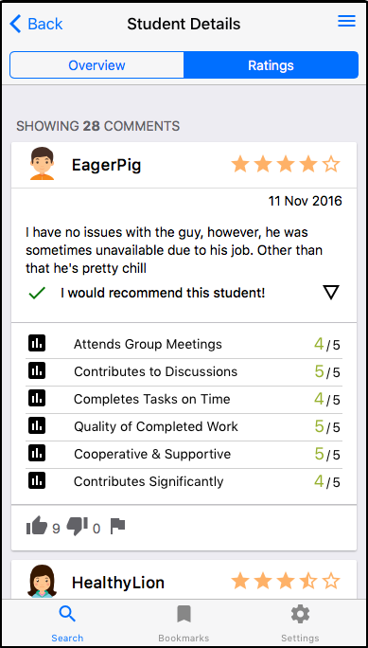

***Figure 4 Figure 5***

## 9.2. Blake Reed – Find Information About Professors and Their Classes

Blake Reed, a graduate student at New York University, wants to find information about information about professors and their classes. The Fall semester is quickly approaching and Blake needs to soon decide which professors he should take. He’s particularly interested whether the professor is knowledgeable in the course material. Blake is a cyber security specialist and wants to take classes with professors that are knowledgeable in the subject. It’s very important to him to learn from the best, so that he can improve his skills and get the most out of the classes he takes.

To help Jake with his decision making, we’ve introduced a set of different categories/characteristics in which reviewers can rate professors. This helps Blake to quickly identify the strong points of a particular professor and, most importantly, whether this professor is knowledgeable in the material he/she is teaching. Additional information that Blake may encounter while looking through professors’ profiles is irrelevant to his initial goal, however, it’s still applicable as Blake might find this information to be useful as well. Below are the steps that Blake would take to find the information he’s interested in.

**Step 1:** Go to the **`Search`** screen and type in the name of the professor in the search bar, for example, **`Renee Porter`** - see **Figure 6** below for details

**Step 2:** Click on the appropriate professor to get more information about him/her and his/her classes – see **Figure 7** below for details

**Step 3:** Scroll down in the **`Overview`** tab to get information about the professors, aggregate ratings, as well as information about his/her classes – see **Figure 8** and **Figure 9** below for details

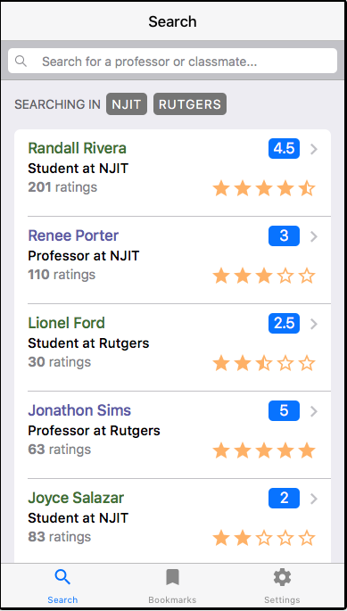 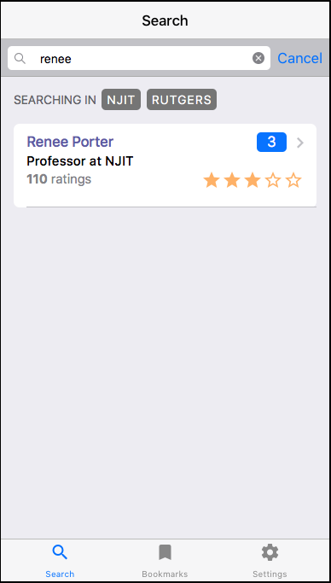 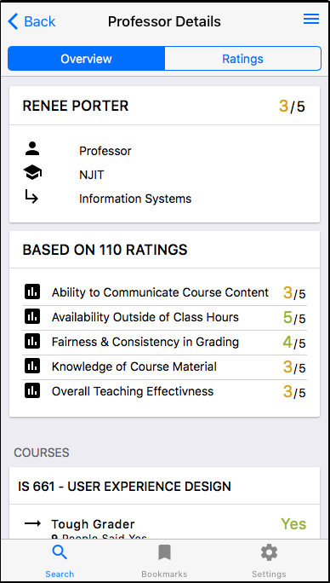

***Figure 6 Figure 7 Figure 8***

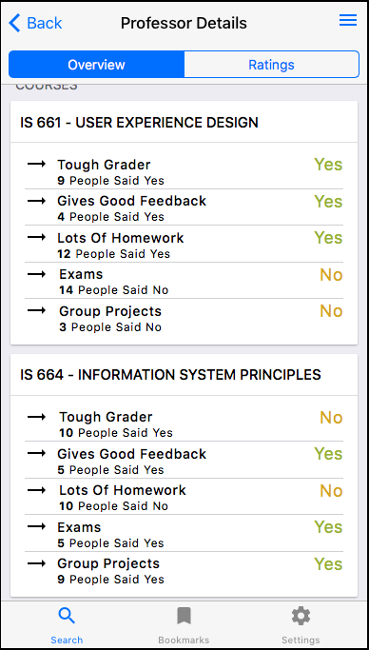

***Figure 9***

**Step 4:** Press the **`Ratings`** tab to see comments and ratings provided individually by students of the professor – see **Figure 10** below for details

**Step 5:** Press the **`arrow down`** icon next to the **`I would recommend this professor!`** to get detailed information about a particular rating – see **Figure 11** below for details

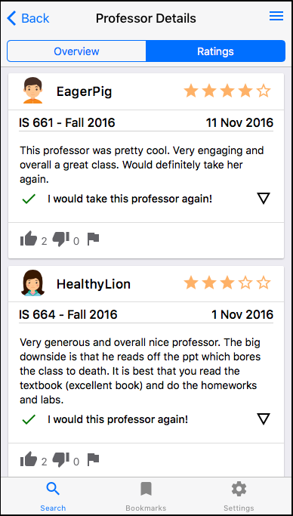 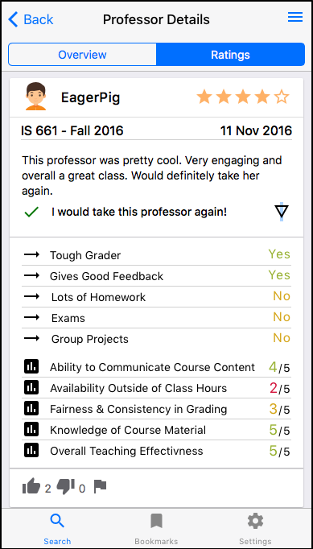

***Figure 10 Figure 11***